Trevor Kirsch

**Homework 2**

*Part 1*

Initialize a 2X2 numpy array with random values. Name this array as ‘x’



Display the contents of the x



Display the type of the x



Display the size of the x



Display the data type of the array elements in x



Force the data in the x to be converted to float type and display the elements



*NOTE: The data type of array x is already in float format*

Create a new array ‘y’ and store the transpose of the above created 2X2 array (i.e. transpose of x)



Do a matrix addition “x+y” and store it as a new array “a” and display the contents of a



Do a matrix multiplication “x*y” and store it as a new array “b” and display the contents of b



*Part 2*

Use subplot function to plot the following functions:

* y=sin(x)
* y=cos(x)
* y=tan(x)
* y=x

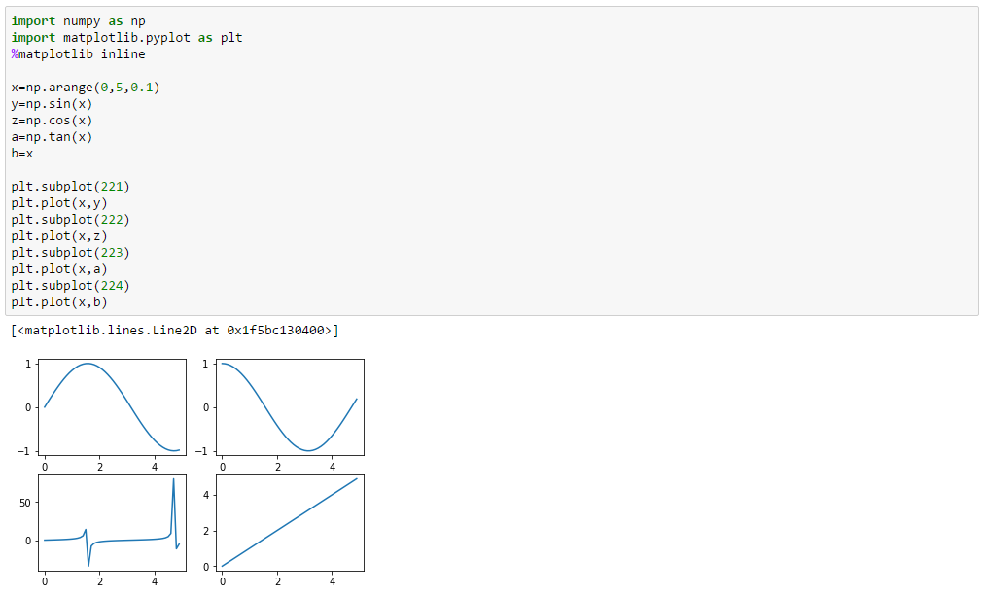

Plot the graphs for the above mentioned functions on the same figure using hold function. Assign different color, thickness, and linewidth for the different functions

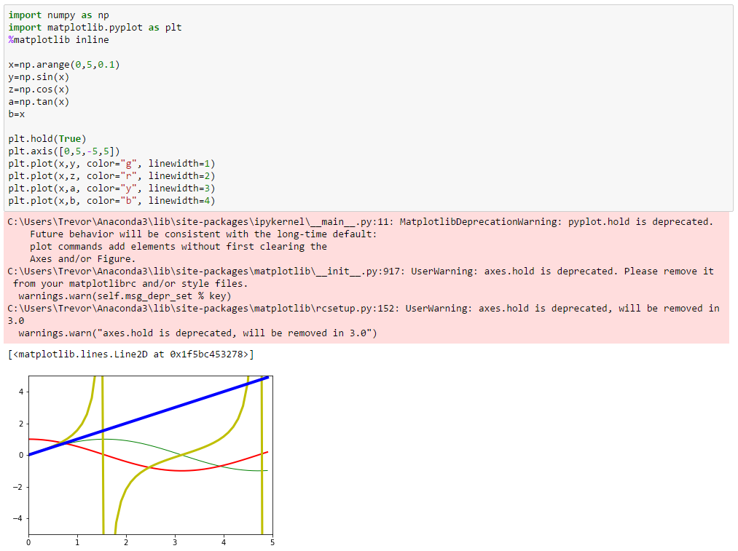

*NOTE: Cannot find the difference between “thickness” and “linewidth”*

Download the monthly_temp_data.csv sheet attached with the homework:

* Import the csv file using csv.reader
* Read the file as a list
* Store the values for temperature column and day in separate lists (remember to remove the headers)
* Plot the graph for Date vs. Temperature with title for the plot as “Day vs. Temperature”, xlabel as Date and ylabel as Temperature

